Steel Bite Pro Review- Is it safe?
Is Steel Bite Pro Legit and Worth Buying?
Steel Bite Pro is a natural supplement for oral and dental hygiene.
This dental hygiene supplement contains active and natural ingredients that help users maintain their dental health with ease. It is one of the most popular natural supplements in the oral health market right now. One of the reasons for this is the unbeatable price at which it is offered. Steel Bite Pro review.
According to the Steel Bite Pro review , Steel Bite Pro is herbal and contains many healthy vitamins and minerals that effectively improve and maintain the cleanliness of the mouth and teeth.

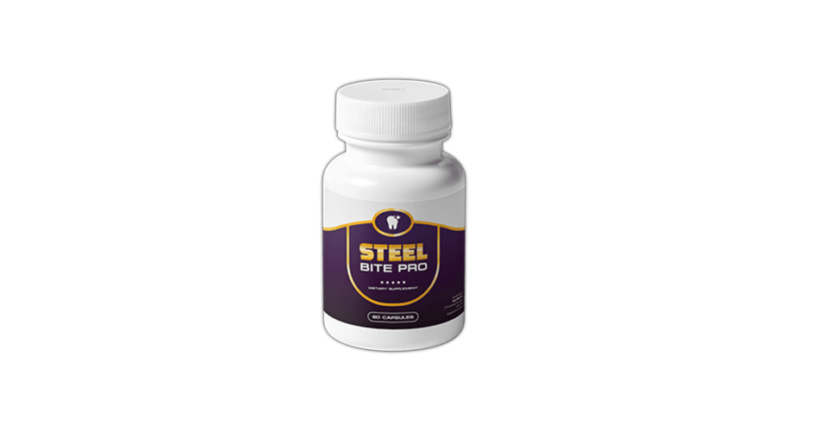
The natural ingredients in dietary supplements are extracted from plants and subjected to laboratory testing to ensure their effectiveness and quality before being bottled together. The preparation does not contain additives or toxins, which makes it completely safe and free from harmful side effects.
In Steel Bite Pro reviews, , Steel Bite Pro Pills use natural ingredients to combat all threats related to dental hygiene in and around the mouth. The supplement is not limited to just the teeth and gums but ensures that the entire mouth is free of harmful bacteria that lead to poor oral hygiene.
Interested consumers are encouraged to purchase Steel Bite Pro at current discounted prices. Get the supplement from the comfort of your home and see how it improves your oral hygiene. Get it from the official website : https://www.phdsc.org/steel-bite-pro-review

